
nsw darts
Policy on Social Media – Social Media Engagement

October 2018

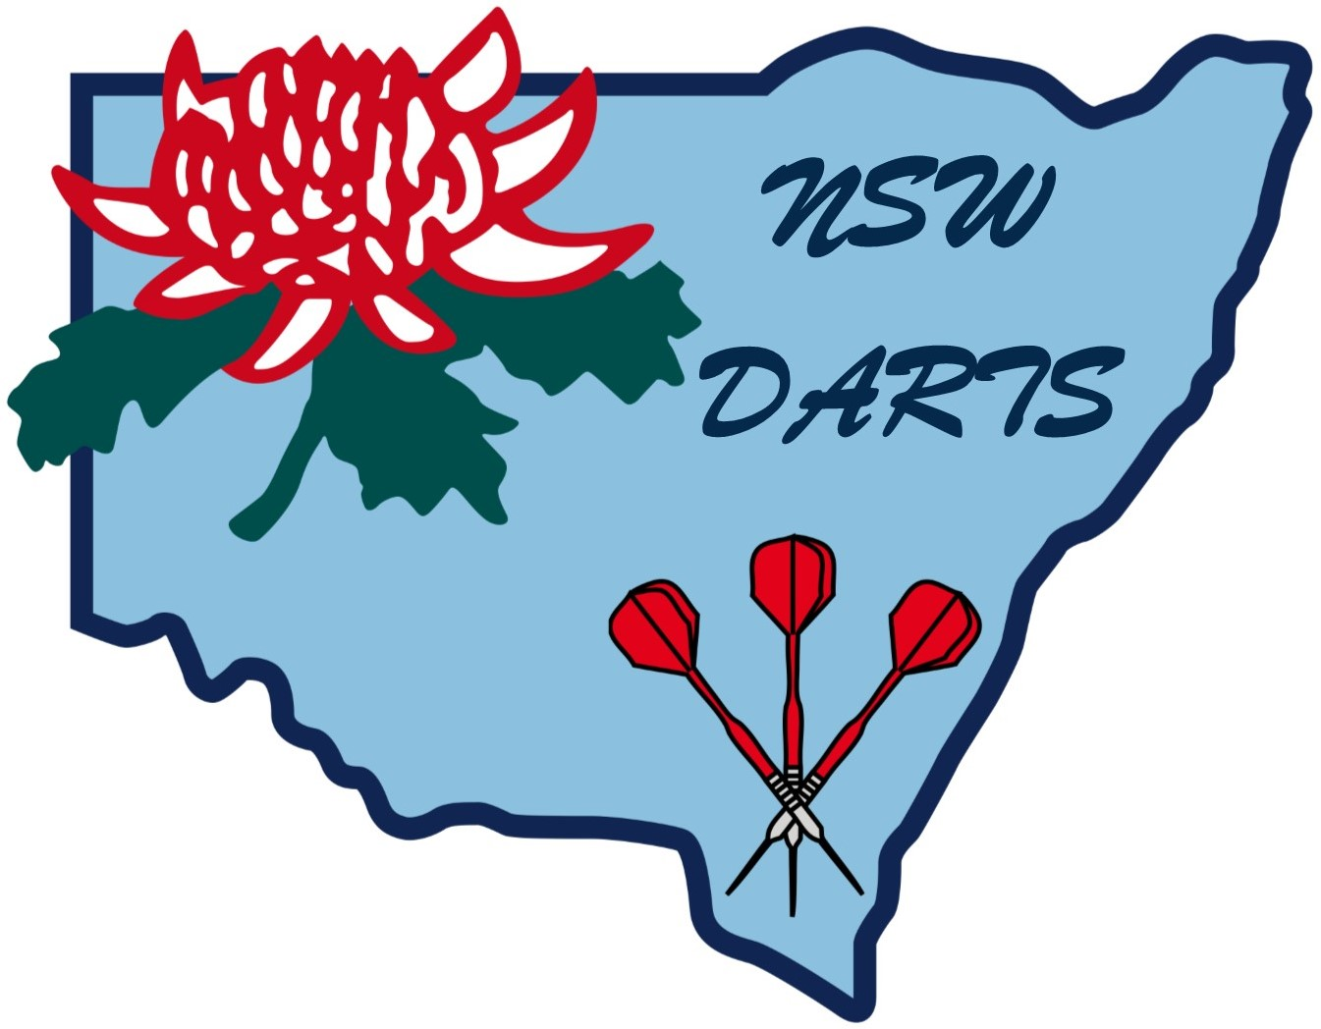
POLICY ON SOCIAL MEDIA – SOCIAL MEDIA ENGAGEMENT

1. Purpose

Social Media provides an excellent opportunity for people to gather in online communities of shared interest and create, share or utilise the content. The interest and participation in social media are growing very quickly and this also extends to organisations who are recognising that social media offers new opportunities to communicate with customers and other communities with shared interests.

New South Wales Darts sees social media as an important tool of corporate and business engagement. Members are encouraged to use social media in a personal capacity to share information and views with friends and communities – both old and new.

With the growth and application of social media, NSW Darts has identified the need to have a policy which ensures that members who use social media either as part of their job, or in a personal capacity, are fully aware of the organisation’s expectations in relation to social media engagement when it is about NSW Darts, our services, our people and/or other business related individuals or organisations. NSW Darts principles of Social Media Engagement are designed to protect the interests of members and the organisation.

The essential guiding principles are:

- Ensure that you are fully aware who you are representing;
- All references to NSW Darts are correct, accurate and in line with the Privacy and Harassment and Social Media Policies of NSW Darts;
- Demonstrate respect for the individual and communities with which you always interact.

Please note that his policy does not apply to a member’s personal use of social media platforms where the employee/member makes no reference to affiliated members or NSW Darts related matters.

2. Application

Social Media Engagement is a policy of NSW Darts and it applies to all NSW Darts members, volunteers, contractors and to any other person who is notified that this policy applies to them. If you require clarification about aspects of this policy and how it applies to your own circumstances, please discuss this with NSW Darts Executive.

Policy
NSW Darts appreciates the value in using social media to build relationships with customers, communities and other relevant stakeholders. If you are officially accredited to represent NSW Darts in social media, or if you are discussing NSW Darts or NSW Darts business related issues in your personal use of social media platforms, you are required to follow this Policy.

Social media tools include:

- Social networking sites e.g. Facebook, Google+, MySpace, Bebo, Friendster
- Video and photo sharing websites e.g. Flickr, YouTube
- Micro-blogging sites e.g. Twitter
- Weblogs, including corporate blogs, personal blogs or blogs hosted by traditional media publications
- Forums and discussion boards such as Whirlpool, Yahoo! Groups or Google Groups
- Online encyclopaedias such as Wikipedia
- Any other sites that allow individual users or companies to use simple publishing tools.

3. NSW Darts Principles of Social Engagement apply as following:

- You are authorised to represent NSW Darts on social media platforms and are using a social media platform for business purposes. Further information is outlined below.
- You choose to make references to NSW Darts, its people, products or services, and/or other business-related individuals or organisations when you are using a social media platform in a personal capacity. Further information is outlined below.

NSW Darts Social Media Engagement Policy does not apply to personal use of social media platforms where you make no reference to NSW Darts or related matters.

4. Social Media Engagement for Business Purposes
Before you operate as a representative of NSW Darts on a social media platform, you must have approval from your manager and demonstrate that you are fully aware of this policy and procedures. This section details how you will represent NSW Darts as part of your job responsibilities.

Representation
You are required to:
- Disclose that you are a NSW Darts affiliated member and be clear about which area you are representing and what your role and accountabilities are;
- Disclose only publicly available information. You must not comment on or disclose confidential NSW Darts information (such as financial information, future business performance, business plans, imminent departure of key executives).
If you require clarification about what NSW Darts information is in the policy domain, you should refer to NSW Darts Executive.

Responsibility
You are required to:
- Ensure that any content you publish is factually accurate and complies with relevant company policies, particularly those relating to confidentiality and disclosure (see Reference section below);
- Ensure that you have received the appropriate internal clearances and approvals in accordance with NSW Darts policy for releasing information in the public domain;
- Only offer advice, support or comment on topics that fall within your area of responsibility at NSW Darts. For other matters, seek advice from management alert, if the situation requires a real time response, let the other party know that the request has reached NSW Darts for response.
- Ensure you do not post material that is obscene, defamatory, threatening, harassing, discriminatory or hateful to another person or entity, including NSW Darts, its members, employees, its contractors, its partners, its competitors and/or other business-related individuals or organisation;
- Ensure you do not disclose other people’s personal information in social media venues and comply with the Privacy Policy.

Respect
You are required to:
- Be respectful of all individuals and communities with which you interact online;
- Be polite and respectful of others’ opinions, even in times of heated discussion and debate;
- Adhere to the Terms of Use, and seek to conform to the cultural and behavioural norms, of the social platform being used;
- Respect copyright, privacy, financial disclosure and other applicable laws when publishing on social media platforms.

5. Personal Uses of Social Media Platforms
This Social Media Engagement policy is applied if you choose to make references to NSW Darts, its people, members or services, its competitors, and/or other business-related individuals or organisations when you are using a social media platform in a personal capacity. It is important in these circumstances that readers of your posts do not misconstrue your personal comments as representing an official NSW Darts position.

Representation
You are required to:
- Identify yourself as a NSW Darts affiliated member or volunteer if you refer to NSW Darts, its people, members and services, its competitors and/or other business-related individuals or organisations;
- Ensure you do not imply in any way that you are authorised to speak on NSW Darts behalf;
- Ensure you do not knowingly use the identity of another NSW Darts member or an employee of a NSW Darts partner or competitor (including name or variation of a name);
- Be mindful during your social media engagements of the importance of not damaging the organisation’s reputation, interests and/or bringing NSW Darts into disrepute;
- Disclose only publicly available information. You must not comment on or disclose confidential NSW Darts information (such as financial information, future business performance, business plans, imminent departure of key executives). If you require clarification about what NSW Darts information is in the public domain, you should consult management.
- Not include NSW Darts logos or trademarks in your postings.

Responsibility
You are personally responsible for the content of your posts online. In this context, you have a responsibility to ensure that:
- Any information about NSW Darts services that you provide is informed and factually accurate. If you wish to express your opinions, please state they are your personal opinions. If you are offering your personal perspective on a matter related to NSW Darts, be mindful that your commentary and opinion does not cause damage to NSW Darts or its interests.

You are required to:
- Use a disclaimer to ensure that your stated views and opinions are understood to be your own and not those of NSW Darts.

A disclaimer is required when you:
- Refer to the work done by NSW Darts;
- Comment on any NSW Darts related issue; or
- Provide a link to NSW Darts website.
- Use a permanent disclaimer if you are referring regularly to NSW Darts or NSW Darts related issues. For irregular NSW Darts references, a disclaimer need only be used on a case by case basis. An example of a disclaimer is: “the views expressed in this post are mine only and do not necessarily reflect the views of NSW Darts”.
- Adhere to NSW Darts Policy on Internet Use if you are using NSW Darts provided services made available to you as a volunteer or a member. In particular, limited personal use of NSW Darts provided services (such as email, internet access and instant messaging) is allowed, however it must be within reasonable limits and not interfere with your work.
- Reference only publicly made available information on www.nswdarts.com.au
- Ensure you are not the first to make a NSW Darts announcement;
- Ensure you do not post material that is obscene, defamatory, threatening, harassing, discriminatory or hateful to another person or entity, including about NSW Darts, its members, volunteers, its contractors, its partners, its competitors and/or other business-related individuals or organisations.

Respect
You are required to:
- Be respectful of all individuals and communities with which you interact online;
- Be polite and respectful of other opinions, even in times of heated discussion and debate;
- Adhere to the Terms of Use, and seek to conform to the cultural and behavioural norms, of the social media platform being used;
- Respect copyright, privacy, financial disclosure and other applicable laws when publishing on social media platforms. Check with management if you are not certain about what you can reproduce or disclose on social media platforms.

6. Breach of Policy
As is the case with all NSW Darts policies and procedures, if you do not comply with this Policy you may face disciplinary action under NSW Darts Constitution. This disciplinary action may involve a verbal or written warning or, in serious cases, suspension or engagement with NSW Darts.

NSW Darts may recover from you any costs incurred because of a breach of this Policy.

If you break the law, you may also be personally liable.

Amended October 2018

