
nsw darts
Policy on Social Justice and Equity

October 2018

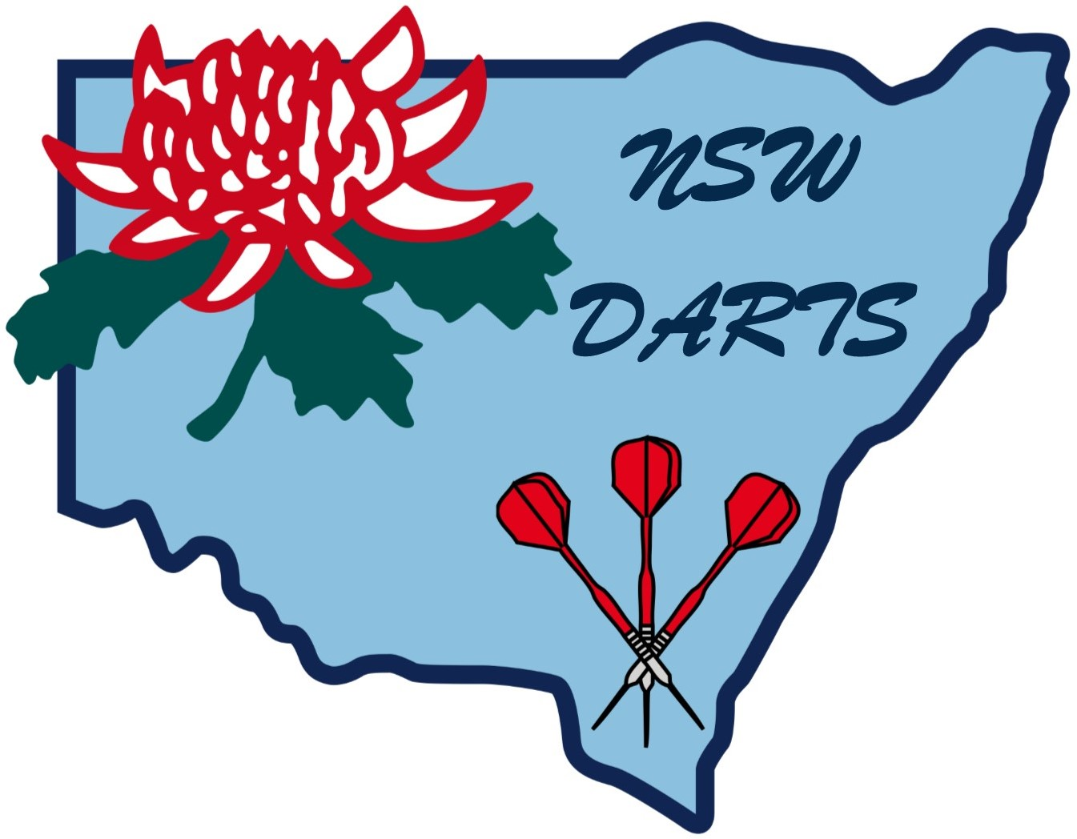

POLICY ON SOCIAL JUSTICE AND EQUITY

1. Policy

1.1 To offer and make available as widely as possible democratic opportunities within New South Wales Darts (Inc.) so as not to deny any person or groups on the grounds such as age, gender, ethnicity, socio-economic status, disability, sexual preferences.

1.2 Arrange sessions to educate key personnel in the sport of darts about issues such as gender equity, discrimination, sexual harassment, and homophobia and about New South Wales Darts (Inc.) legal responsibilities.

2. Age

2.1 To involve all people regardless of their age in participating, decision making and program development particularly in the Junior and Mature Age groups.

2.1.1 Create special promotion days and opportunities for mature people to become acquainted with our sport and have the promotion days conducted by mature people.

2.1.2 Treat mature people in the sport of darts with respect and in the same way as other members. Refuse to tolerate discriminatory jokes, language, behaviour and imagery. Recognise mature people’s achievements and contributions within the sport of dart.

2.1.3 Arrange sessions for mature people to improve and update their knowledge level and that of other key members of the sport of darts.

2.1.4 To establish modification of the sport of darts to suit our various age groups.

3. Gender

3.1 Ensure men and women have equal opportunity to be represented on policy and decision-making committees.

3.2 Encourage more people, both men and women, to become qualified officials and to aspire to higher levels of officiating.

3.3 Ensure equality between the sexes in funding, sponsorship, media coverage, T.V. exposure, time, space, equipment, and access to quality programs to participate and compete.

4. Aborigines and Torres Strait Islanders

4.1 Understand that sport and recreation is as important to Aboriginal as it is to the broader community.

4.2 Provide programs in areas where Aboriginal and Torres Strait Islander people can access.

4.3 Enlist the help of local indigenous people in getting information on the sport of darts to indigenous communities.

4.4 Be aware that many Aborigines and Torres Strait Islanders will be reluctant to approach a predominantly white sporting Association/Club. Encourage and support anyone who shows an interest in the sport of darts.

4.5 Be flexible and be prepared to make allowances for culture differences.

4.6 Appreciate the need to spend more time in motivating young Aborigines and Torres Strait Islanders.

4.7 New South Wales Darts (Inc.) should become acquainted with the Aborigines and Torres Strait Islanders available media radio and T.V. outlets.

5. People with Disabilities

5.1 Learn about people with disabilities to dispel any misunderstandings or ignorance, negative attitudes or adherence to inappropriate stereotyping. Appreciate that people with disabilities are not a homogenous group.

5.2 Recognise that if young people are to learn the benefit from the sport of darts, it is important that they receive the opportunity to do so before their fitness and skill levels fall too far behind those of their able-bodied peers.

5.3 Make links with the key disability organisations involved in Australia.

5.4 comprehensively examine the sport of darts to determine how it could make allowances to accommodate people with disabilities, time slots, resources, modified rules, etc.

5.5 Consider the physical accessibility of our sporting venues and facilities for:

5.5.1 Toilets (male and female or one unisex facility) and showers that are accessible and available with appropriate handrails.

5.5.2 Car parking with bays wide enough for wheelchair access.

5.5.3 Ramps with appropriate gradients.

5.5.4 Doorways of sufficient width telephone and lift buttons at appropriate heights.

5.5.5 Sufficient lighting.

5.6 Update Accredited Coaches:

5.6.1 Arrange for Accredited Coaches to attend CAD courses

5.6.2 Make allowances to include CAD components in Sports Specific Course section and generic coaching courses

5.6.3 Ensure techniques and attitudes to coaching are flexible, adaptable and responsive to individual needs, concentrating on abilities and disabilities

5.6.4 Ensure all players’ needs are treated as individuals with strengths and weaknesses, to be set challenging and realistic goals and to receive clear communication and positive feedback.

5.7 Promotion

5.7.1 Include positive images of people with disabilities in our promotional material.

5.7.2 Ensure the players’ efforts receive appropriate recognition in the media. Insist stories on their efforts appear as sports articles.

5.7.3 Encourage role models and help address the negative stereotyping.

6. People in Isolated Communities

6.1 Leadership

Recognise and identify interested people such as parents, teachers and young adults and skill them so that they can teach others.

6.2 Communication

6.2.1 Arrange personal communication, newsletters.

6.2.2 Develop video or correspondence resource packages (including equipment) for teaching basic technique and coaching, administration and officiating skills.

6.2.3 Develop resources on financial planning such as applications for funding.

6.2.4 Identify the networks of people from the Government Departments who can assist them.

6.2.5 Make funding available to support the travel costs of officials to attend seminars conducted in their Capital Cities.

6.3 Seminars

Take programs to these areas such as regular coaching clinics, coaching and accreditation workshops, or darts development programs.

7. People from Non-English Speaking Backgrounds

7.1 Advice

Seek advice from the Bureau of Ethnic Affairs and The Ethnic Communities Council on how to culturally develop the sport of darts within the non-English speaking community.

7.2 Communication

7.2.1 Arrange cross-cultural training for coaches who are likely to be working with a non-English speaking population.

7.2.2 Word of mouth has shown to be most effective.

7.2.3 Be very flexible and be prepared to make allowances for culture difference.

8. Unemployed People

8.1 Recognise

8.1.1 Unemployment is just one layer of hardship for many people, including those with disabilities, Aborigines and Torres Strait Islanders and people from non-English speaking backgrounds.

8.1.2 Most people want to feel they are making a contribution to the community. Develop darts leadership programs and give them the opportunity to learn new skills and by doing so put something back into society.

8.2 Facilities

Provide crèche facilities to encourage sole parents particularly women with participants.

Amended October 2018

