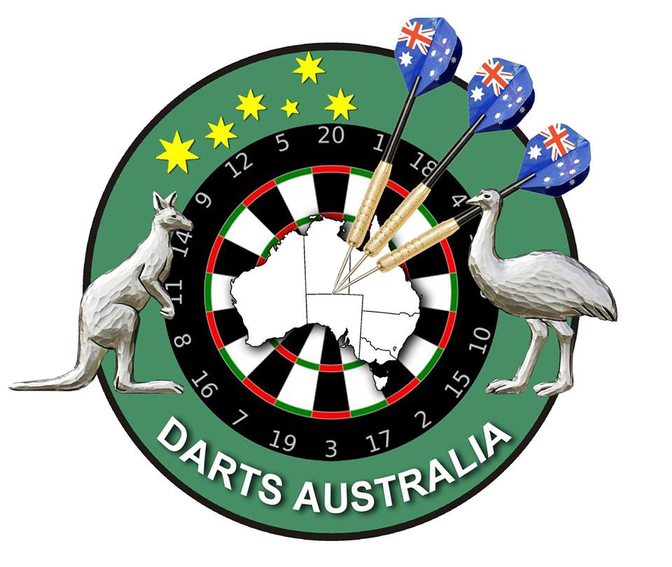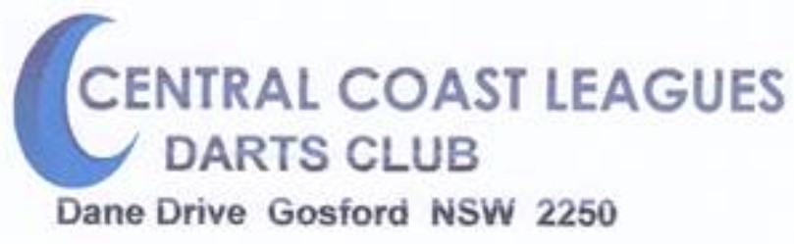
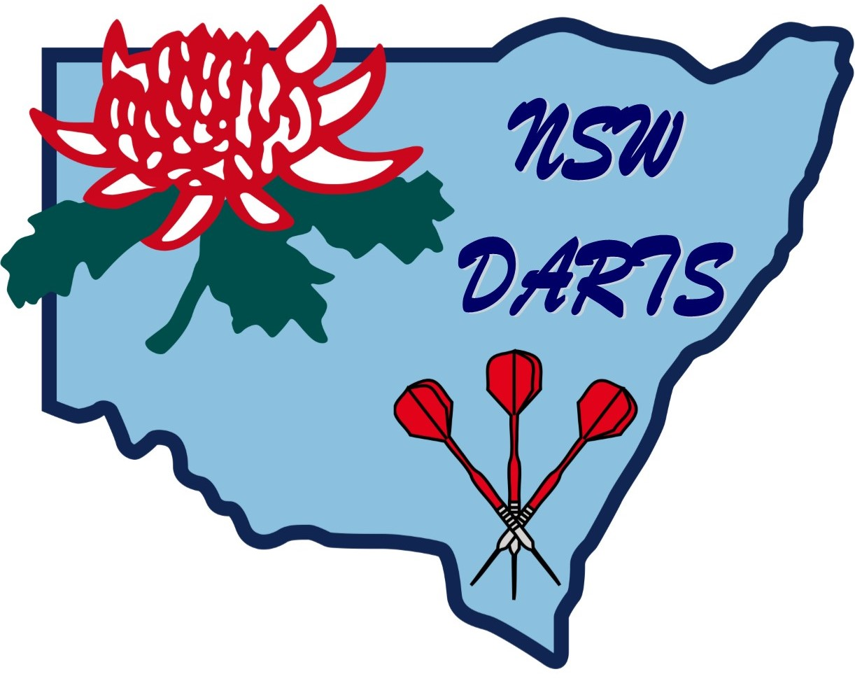SILVER CLASSIC
1st & 2nd May 2021
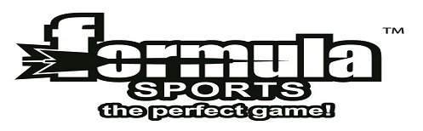DA & NSW Points
Prize Money $3,000.00 (Subject to Nominations)

Saturday 1st May Sunday 2nd May
Doubles Singles
Unseeded
Round Robin Round Robin
Board System Board System
Enquiries: Central Coast Leagues Club 02 4325 9888 Heather Scott 0412 050 448
Email: bobweaver@optusnet.com.au

Doubles Singles
Gentlemen Ladies Gentlemen Ladies
1st: $300.00 $300.00 1st: $350.00 $300.00
2nd: $180.00 $145.00 2nd: $180.00 $150.00
3rd-4th: $60.00 $60.00 3rd-4th: $70.00 $60.00
5th-8th: $30.00 $30.00 5th-8th: $30.00 $25.00
9th-16th: $15.00 N/A
All Doubles payouts are per Team
Singles payouts are per person
Most 180’s over 2 days: Ladies $20.00 / Gents $20.00
Highest Peg: Ladies $20.00 / Gents $20.00
Entry Fees:
Doubles: $30.00 per team Singles: $15.00 per person

Entry fee includes Capitation Fee
$1.00 NSW $3.00 DA

Nominations Close:
9.30am Saturday for Doubles & 9.30am Sunday for Singles

CCLC reserves the right to refuse any nomination

To receive DA and NSW Points, it is the players’ responsibility to be a financial member of the DA and/or NSW Darts in the year of the Tournament.

